Capital Projects Gateways Process Appendix1

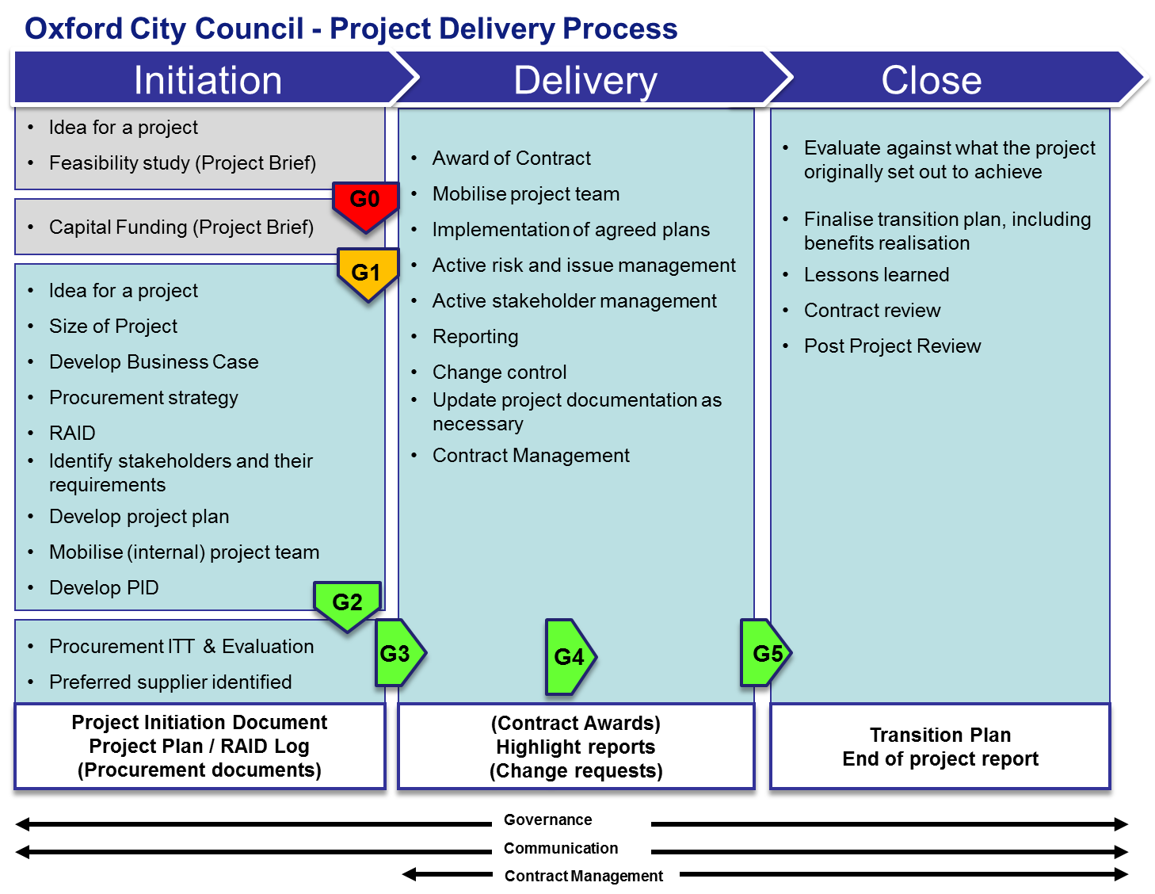

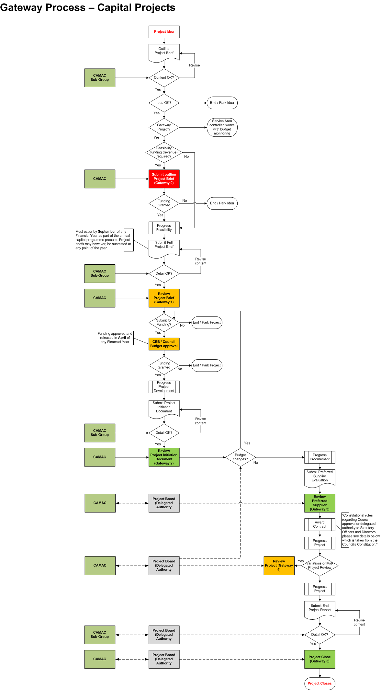

Governance and Assurance Gateways
Capital funding bids and where funding is approved, select projects will pass through a series of governance and assurance gateways. The governance and assurance gateways are designed to ensure that the bids and a project’s progress are monitored and assessed through a robust process aligned to the Capital Strategy.
The Gateway process will require specific documentation to be completed and submitted for review and challenge at various stages. As capital funding bids are to be submitted by September of any year, and funding is approved, ready for release during the new Financial Year (beginning April), the documentation requirement will ensure that capital expenditure or capital project details and its associated business case are recorded, in a consistent manner, so that any scheme can continue with all parties understanding the proposed outcomes and costs.
Some schemes will not become ‘Gateway projects.’ Though the capital expenditure will need to be understood for aspects such as vehicle replacement, or fencing maintenance, these will not be subject to the Gateway Process other than the first stage (Gateway ‘0’ (zero)). These aspects will be managed within Service Areas and be subject to budget monitoring
Once a project has been approved, as well as governance and assurance gateways, monitoring reports will be required, for review by the Corporate Asset Management and Capital (CAMAC) Programme Board.
Governance arrangements for a project are to be proposed to CAMAC, who will revise or ratify the arrangements. Should responsibility for the project be delegated by CAMAC, the delegated authority (typically a Project Board), will be responsible for the completion of any governance and assurance. Monitoring reports, regarding the Capital Bid and Projects will continue to be submitted for review by CAMAC irrespective of whether authority has been delegated or not.
Note: Roles and responsibilities associated with capital projects are described below.

Required Documentation
All activity, where capital funding is required, should be described using a Project Brief template to enable information to be captured in a consistent manner. Capital ‘Gateway projects’ will be required to complete, as a minimum, four documents (over the course of the project) that will apply at the various stages from concept through to completion. The documents required are:
Note: Template examples of the documentation are provided within the appendices.

Project Brief | This document enables a Sponsor and project manager to describe the proposed project or scheme in terms of background, objectives, scope, constraints (including risks), cost (including a proposed profile of spend), approach, options and benefits.  The document also enables Service Areas to describe maintenance or replacement works that are to be carried out.  The information contained will enable CAMAC to determine whether the idea should be progressed (Gateway 0 (zero)) and a funding bid submitted to CEB / Full Council (Gateway 1) as a Gateway Project or to be Service Area managed with budget monitoring.  Notes:  - A Project Brief template should be used where 'match funding' financing is required. Using this template and submitting the information to CAMAC will enable the idea and budget to be considered and approved. Where there are short deadlines for funding, rather than wait for the next Capital Programme Management meeting or full CAMAC Board, an exceptional meeting would be appropriate.  - Where a project is managed by an external party, e.g. Oxfordshire County Council, the project should be described using the project brief template. This should incorporate the City Council's financial commitment so that the idea and budget can be considered and approved. A City Council Lead Officer should be appointed, so that the project may be tracked in terms of progress and expenditure.
Project Initiation Document (PID) | Where the Funding Bid has been approved by CEB / Full Council (Gateway 1), CAMAC will request that the project be fully planned and documented.  The starting point for the completion of the Project Initiation Document (PID) will be to copy the information from the Project Brief.  A PID will be required for projects whose cost is in excess of £100,000  The PID requires significant effort and planned activity to collect and prepare all of the required detail.  Note: Once work begins on the PID, the Project Brief may be discarded.  The information contained will enable CAMAC (or a delegated authority) to determine whether the project should continue and along with any procurement activity, whether preferred resource or suppliers may be contracted (Gateways 2 and 3 respectively).  The CAMAC, or the delegated authority will ratify any project tolerance and contingency that has been proposed. Tolerance and contingency should be considered in terms of Cost, Time, and Quality and this should be linked to the risk register for the project  Once the PID has been agreed, the scope of the project and its deliverables are fixed. Any changes to this would be addressed through agreed tolerances, or where significant, through requests for change to CAMAC (Gateway 4).
Project Monitoring Tool | This tool enables the project manager to indicate the progress and status of a project through responding to a small number of questions.  The tool presents a status and enables the capture of comments, actions and owners.  This tool will remain ‘live’ for the duration of the project and should be completed as each stage progresses. The monitoring tool is stored on a central network drive and the Project Manager will update the details on a monthly basis. Finance will collate the information provided and will update the Capital Programme Report that is reviewed by the CAMAC.  Note: Where ICT projects are capitally funded, these projects should also be reported to CAMAC through the use of the Monitoring Tool, even though it would be the Organisational Development and Corporate Efficiency Programme Board which is responsible for the project’s delivery
Project Closure Statement | Where CAMAC or the delegated authority has agreed that the project has been completed, the project manager will complete a Project Closure Statement.  The starting point for the Project Closure Statement is the PID. The report enables the assessment of the project in terms of products or services delivered, benefits, outstanding risks and lessons learned.  The detail required within the report will be proportionate to the size and complexity of the project.

Governance and Assurance Gateways – requirement and timing
Capital funding bids and subsequent Gateway Projects will be governed through a series of six Gateways; numbered zero through five.
Gateways ‘zero and one’ relate to funding Bids that are to be submitted by September of any year.
Gateways ‘two through five’ relate to CEB / Full Council approved projects and their subsequent progress following the release of capital from April of any year.
The purpose and documentation requirements for each gateway are:
Gateway Zero | Purpose  - A Sponsor and a project manager wish to propose a project /scheme. This project/scheme may need to carry out surveys, a feasibility study or an options appraisal, in order to establish the viability of a capital funded project, and are seeking revenue funds in order to progress.  - A Service Area requires a capital expenditure programme of works e.g. vehicle replacement, or fencing maintenance  - Gateway 0 (zero) enables CAMAC to make a determination on whether the scheme is appropriate and aligned to the Capital Strategy, and also whether feasibility funding is to be granted.  - The result of this stage will be:  - Gateway Project - subject to Full Gateway process  - Not a Gateway Project - Service managed works an reviewed through budget monitoring  Documentation required  - An project brief should be completed, outlining the project idea or expenditure programme
Gateway One | Purpose  - CAMAC have approved the scheme as a Gateway Project at Gateway 0 (zero).  - A Sponsor and a project manager are seeking internal approval to formally request the required funding via CEB / Full Council  Documentation required  - A fully completed project brief, describing the project
CEB / Full Council determine whether funding is to be granted and committed
Gateway 2 | Purpose  - CEB / Full Council have approved the required funding for the project/.scheme  - To review requests to formally begin the project to planned timescales and to authorise the commencement of procurement activity based on an approved procurement strategy.  Note: No tender process will commence unless the specification is affordable within the budget that has been approved. For example, the specification indicates a cost of £1.5 million, however the budget provision is set at £1.3 million  Additionally, the tender process will not commence until the Internal Project Manager has checked and approved the design specification.  - To fully understand the cost of the project including requesting additional budgetary provision from CAMAC (via report to CEB / Full Council  - To ensure that all internal resource requirements are captured and recorded within the PID. This would include resource from Procurement, Legal and Finance.  Notes:  Where the costs of the project change, the options to address this are:  - Value engineered to achieve the approved budget figure  - Can money be vired from another part of the Capital Programme to cover the shortfall?  - Does the scheme need to go back to CEB / Full Council to request the additional funding?  - Where these options are not appropriate, Full CAMAC may determine to stop the project from continuing.  Documentation required  - A fully completed Project Initiation Document
Gateway 3 | Purpose  - CAMAC have approved the project/scheme at Gateway 2  - To evaluate tender responses and approve recommendations to proceed with a preferred supplier or suppliers  - To fully understand the cost of the project including requesting additional budgetary provision from CAMAC (via report to CEB / Full Council  Notes:  Where the costs of the project change, the options to address this are:  - Value engineered to achieve the approved budget figure  - Can money be vired from another part of the Capital Programme to cover the shortfall?  - Does the scheme need to go back to CEB / Full Council to request the additional funding?  - Where these options are not appropriate, Full CAMAC may determine to stop the project from continuing.  Documentation required  - A revised and fully updated Project Initiation Document  - Procurement Strategy template (completed with Procurement)  - Preferred supplier tender evaluation report/s
Gateway 4 | Purpose  - CAMAC have approved the project/scheme at Gateway 3 and any contract award has been approved following the rules set out in the Constitution.  - Project Boards (as delegated authorities) will manage the day-to-day delivery of the project/scheme and any tolerances/contingency  - Should there be exceptional changes (outside of agreed tolerances/contingency relating to costs, viability, quality and timescales established by the appropriate authority and ratified by CAMAC) then the project should submit Change Request documentation to the Capital Programme Management group. This will trigger a Gateway 4.  - CAMAC may wish to request a Gateway 4 as an external pair of eyes  Notes:  Where the costs of the project change, the options to address this are:  - Value engineered to achieve the approved budget figure  - Can money be vired from another part of the Capital Programme to cover the shortfall?  - Does the scheme need to go back to CEB / Full Council to request the additional funding?  - Where these options are not appropriate, Full CAMAC may determine to stop the project from continuing.  Documentation required  - The agreed Project Initiation Document  - Change Request documentation  - Monitoring tool to assess current progress
Gateway 5 | Purpose  - CAMAC have approved the project/scheme at Gateway 3  - Project Boards (as delegated authorities) are requesting formal closure of the project/scheme  - To review the completed project and to assess its successes and any lessons learned.  Documentation required  - A Project Closure Statement  - Monitoring tool to assess current progress

Appendices
Project brief (template)
Project initiation document (template)
Project governance / project monitoring tool
Project Closure Statement (template)

Capital Projects process and governance

Structure, Definition of Roles and Responsibilities

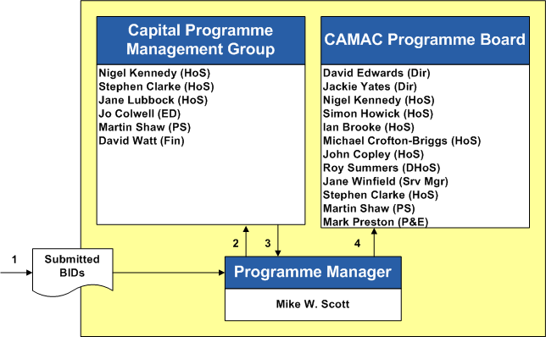

Overall Structure
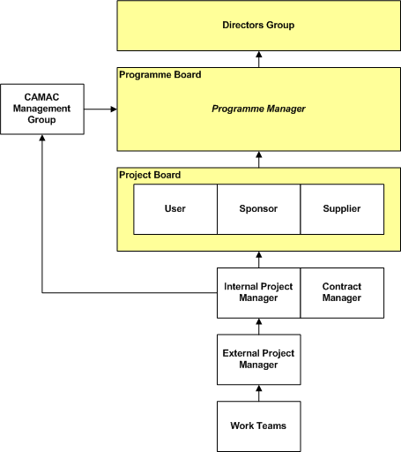

Note: two Project Management configurations are described as follows:
- Management Structure 1 : Internal Project Manager appointed
- Management Structure 2 : External Project Manager appointed

Structure, Definition of Roles and Responsibilities

Roles and Responsibilities
Directors Group) | The Group which are accountable for the successful delivery of the Corporate Programmes and who have control over the resources allocated to it.  Provides support, advice and dispute resolution.  Appoints a Senior Responsible Officer to the Programme Board.  The Chief Executive chairs the Directors Group

Programme Sponsor | The person, appointed by Directors Group, who is accountable for the successful delivery of a programme, who has control over the resources allocated to it, and to whom the programme manager reports progress and escalates issues for resolution.  The programme sponsor chairs the programme board
Programme Board | A group that monitors and manages the progress of a programme and are responsible for delivering the programme outcomes and benefits.
CAMAC Programme Board | A group that monitors and manages the progress of a programme and are responsible for delivering the programme outcomes and benefits.  The Terms of Reference for CAMAC are:  To Review Policy and Strategy in respect of:  - Asset Management Plan  - Capital Strategy  - Investment Property Strategy  - Health & Safety  - To manage the implementation of annual capital programme.
Capital Programme Management Group | This group will review all submissions where capital funding is required. These submissions may relate to:  - A Sponsor and a project manager wish to propose a project /scheme.  - A Sponsor and a project manager wish to propose a project /scheme and this project/scheme may need to carry out surveys, a feasibility study or an options appraisal, in order to establish the viability of a capital funded project, and are seeking revenue funds in order to progress.  - A Service Area requires a capital expenditure programme of works e.g. vehicle replacement, or fencing maintenance  The group will collate, advise on, prioritise, prepare determine whether the scheme is appropriate and aligned to the Capital Strategy, and also whether feasibility funding is to be granted. The group will submit the capital bids, to the CAMAC for approval.  The initial outputs of this group will be to determine:  - Gateway Project - subject to Full Gateway process  - Not a Gateway Project - Service managed works an reviewed through budget monitoring  - Not a viable scheme  Where funding has been approved, this group will ensure that No tender process will commence unless the specification is affordable within the budget that has been approved. For example, the specification indicates a cost of £1.5 million, however the budget provision is set at £1.3 million  Additionally, the tender process will not commence until the Internal Project Manager has checked and approved the design specification.  Part of this arrangement will also be the monitoring of current capital schemes and reporting to the CAMAC on an exception basis and receiving advice and guidance where required.  Where disputes on project arrangements are identified, this group will facilitate their resolution through escalation to the CAMAC and to the Senior Responsible Officers Group.
Programme Manager | The person with responsibility for ensuring the delivery of the programme on a day to day basis.  The programme manager will receive the capital funding bid papers and will submit them to the programme sub-group for review.  Receives an aggregated monitoring report (project status information collected from project managers) via Finance for review and discussion by the CAMAC.

Project Board | A temporary, flexible organisation created to co-ordinate, direct and oversee the completion of a project against the agreed business case.  This governance group is responsible for providing the project sponsor with support, advice and technical input.  Approves the appointment and defines the objectives and the responsibilities of the Project Manager.  Works within tolerances set by the programme board for ensuring the project is on track to deliver agreed outcomes in the agreed Project Initiation Document (PID)  Monitoring project progress and assists the project manager with problem resolution, whilst also providing guidance on the direction of the project.  Carries out gateway reviews where this responsibility has been delegated by the programme board.  The project board consists of three roles:  - Project Sponsor  - Senior user  - Senior supplier  Note: Project Sponsor and Senior User may be the same person for smaller projects.
Project Sponsor | The senior person with a relevant interest in the project benefits.  This person is the owner of the business case, and is accountable for the delivery of the project in line with the agreed business case.  This person is able to allocate resources, approve scope changes and provide high-level direction.  This person chairs the project board and would typically sit on the programme board.  Specific Responsibilities  - Oversees the development of the Project Brief and the Business Case  - Ensures that there is a coherent project organisation and a logical set of plans  - Monitors and reviews the project against the business case.  - Ensures risks are being monitored and mitigated as effectively as possible  - Approves the project Closure Statement and that outstanding risks and issues are documented and passed on to the appropriate resource.  - Ensures that project benefits have been realised  For Gateway 0 (zero)  Works with a project manager to develop the outline brief for consideration by CAMAC and aligned to the Capital Strategy.  Seeks funding for any feasibility study.  Nominates an officer to take forward the idea which may or may not include carrying out some discrete procurement to deliver feasibility studies.  Following Gateway 1  The Sponsor is to be consulted to ensure that the procurement strategy meets the requirements of the project in terms of timeline, budget and business outcomes.  The Sponsor must approve to the procurement strategy before it is submitted to CAMAC for approval.  The Sponsor needs to ensure the project manager follows the terms of the Framework for Commercial Contracts to ensure:  - Lead Contractors develop a relationship with Oxford Direct Services (ODS)  - Where there is work that can be separated from the main contract e.g. Landscaping, Highways, ODS are contacted to discuss their ability to carry out the works  - Where there are suitable, discrete work packages, the Lead Contractor meets with ODS to discuss options for them tendering for the work  - Where the project is not suitable for ODS, that consideration is given to ODS’ expertise and in becoming part of the tender evaluation panel  Following Gateway 2  The Sponsor is Accountable for the sign-off of the final tender specification before release to market.  Informed of the outcome of the tender evaluation via a formal report  Depending on the contract value and CEB Delegated Authority given, the appropriate Director will give approval to award the contract in accordance with the tender evaluation report.  Responsible for agreeing the Contract Manager.  Following Gateway 3  Responsible for reviewing and agreeing the final draft contract before it is given to Legal for signing  Accountable for the delivery of the project in accordance with the agreed PID and awarded contract.  Informed of project delivery progress at each project board and changes managed through the Gateway process.  Note: Project Sponsor and Senior User may be the same person for smaller projects.
Senior User | This person represents the interests of all those for whom the project will achieve an objective or who will use the outcome of the project to deliver benefits.  This person is responsible for ensuring project requirements are fully and accurately specified in the business case and for monitoring the quality of the outcomes.  so that they meet the needs of the organisation in terms of quality and use  Specific Responsibilities  - Ensures that the desired outcome is specified  - Promotes and maintains focus on the desired outcome  - Resolves user requirement and priority conflicts  - Advise user management on matters concerning the project  - Ensure that user requirements are accurate and unambiguous  - Risks to users are monitored
Senior Supplier | This role (may be an individual or a variety of individuals over the course of a project) on the project board provides knowledge and experience of the main areas involved in producing the project’s deliverables, such as of those who will design, develop or procure the project’s products.  This role will represent the suppliers’ interests within the project and has the authority to commit or acquire supplier resources in support of the design, development, facilitation, procurement and implementation of the project deliverables.  During the early phases of the project process, Procurement, Legal and Finance will occupy this position – see relevant sections below.  Specific Responsibilities  - Agree objectives for supplier activity  - Promotes and maintains focus on the desired outcome  - Ensures supplier resources are made available  - Resolves supplier requirement and priority conflicts  - Advise non-technical management on supplier aspects of the project  - Ensure that supplier and operating standards defined for the project are met  - Risks regarding production are monitored

Management Structure 1 : Internal Project Manager appointed
Internal Project Manager | Appointed by the project sponsor to plan and deliver the project on a day-to-day basis on behalf of the project board within the tolerances allowed by the board.  Responsible for producing the required deliverables that will support the business case, to the required standard of quality and within the constraints of time and cost.  The project manager must have the necessary skills and experience to undertake this role.  Reports on progress via timed highlight reports submitted to the project board via the programme manager.  Specific Responsibilities  - Directs the project team  - Plans and monitors progress of the project  - Manages the project risks and issues  - Prepares revised plans and documentation through a change control process and presents them to the Project Board  - Agree the technical and quality requirements of the project with the project board  - Prepares the Project Closure Statement including lessons learned and presents it to the Project Board  For Gateway 0 (zero)  Works with a project sponsor to develop the outline brief for consideration by CAMAC.  Following Gateway 1  The Project Manager is Responsible for the production of the Procurement strategy.  This is to be produced with input from Procurement, Legal and Finance.  The Sponsor is to be consulted to ensure that the strategy meets the requirements of the project in terms of budget, timeline and business outcome.  The Internal Project Manager submits the completed strategy to CAMAC for approval  Notes:  Work with the Sponsor to ensure the project follows the terms of the Framework for Commercial Contracts to ensure:  - Lead Contractors develop a relationship with Oxford Direct Services (ODS)  - Where there is work that can be separated from the main contract e.g. Landscaping, Highways, ODS are contacted to discuss their ability to carry out the works  - Where there are suitable, discrete work packages, the Lead Contractor meets with ODS to discuss options for them tendering for the work  - Where the project is not suitable for ODS, that consideration is given to ODS’ expertise and in becoming part of the tender evaluation panel  Following Gateway 2  Responsible for ensuring the procurement strategy is signed-off.  Responsible for arranging for the technical specification to be developed to the timeline agreed in the Procurement Strategy.  The Internal Project Manager is responsible for consulting with other technical staff and preparing the technical specification and providing to Procurement to finalise the full tender documentation.  Responsible for signing-off the completed Technical Specification to ensure it meets the Councils requirements, fit for purpose and provides value for money.  Responsible for submitting the final tender documentation for approval by the Sponsor  Responsible for the coordination of answers to all clarification questions and for approving the tender clarification responses  Responsible for undertaking the tender evaluation as a panel member (subject to Council agreement)  Responsible for the production of the technical elements of the tender evaluation report and submitting it to Procurement.  Responsible for ensuring that the requirements proposed in the final technical solution are fit for purpose and within the project budget.  Submits the evaluation report to the Project Board and to the officer with delegated authority to award the contract.  The Internal Project Manager at this point may become the Contract Manager for the project. This assignment needs to be agreed by Sponsor  Following Gateway 3  Responsible for ensuring that the monitoring arrangements of performance and KPIs are in place.  Receives and reviews contract performance data and reports  Responsible for the day-to-day delivery of the project against agreed plans.  Responsible for ensuring that the project is being delivered in accordance with the contract.  Responsible for producing highlight reporting to the project board and  Responsible for producing the monitoring report for the CAMAC.  Responsible for managing the relationship with external suppliers where relevant, clearly setting out the roles, responsibilities and standards  Monitors performance (e.g. compliance with conditions, KPIs and milestones) and manages the associated risks  Ensures that effective communication is maintained between all parties and monitoring conflicts of interest and facilitates their resolution  Managing operational changes or variations to the contract and ensures contract documentation is regularly checked, e.g. insurance certificates  Working with Procurement to ensure that the contract remains competitive in the current market, and that it continues to demonstrate value for money to the Council  Responsible for submitting requests for change beyond agreed project tolerances.  Responsible for ensuring the appropriate reporting is passed to CAMAC for review.

Management Structure 2 : External Project Manager appointed
Internal Project Manager  [May also be the Contract Manager] | Where insufficient capacity or skill is available within the Council, the Project Sponsor may choose to appoint an ‘external’ project manager to plan and deliver the project on a day-to-day basis.  The Internal Project Manager will act on behalf of the project board and will advise on constraints laid down by the board. The role will act within an assurance capacity.  Reports on progress via timed highlight reports submitted to the project board via the programme manager.  Specific Responsibilities  - Directs the External Project Manager where one has been appointed  - Ensures the External Project Manager understands the Council requirements regarding Project and Programme controls, including Gateways.  - Monitors progress of the project against agreed plans  - Monitors the project risks and issues on behalf of the Council  - Agrees revised plans and documentation through a change control process and presents them to the Project Board  - Agrees the technical and quality requirements of the project with the project manager and presents them to the project board  - Approves the Project Closure Statement including lessons learned and presents it to the project board  Following Gateway 1  The Internal Project Manager is accountable for ensuring that the Procurement strategy is produced.  Notes:  Work with the External Project Manager (and Lead Contractor) to ensure they follow the terms of the Framework for Commercial Contracts to ensure:  - Lead Contractors develop a relationship with Oxford Direct Services (ODS)  - Where there is work that can be separated from the main contract e.g. Landscaping, Highways, ODS are contacted to discuss their ability to carry out the works  - Where there are suitable, discrete work packages, the Lead Contractor meets with ODS to discuss options for them tendering for the work  - Where the project is not suitable for ODS, that consideration is given to ODS’ expertise and in becoming part of the tender evaluation panel  This is to be produced with input from the Project Manager, Procurement, Legal and Finance.  The Internal Project Manager is responsible for submitting the strategy to CAMAC for approval.  Following Gateway 2  Responsible for ensuring the Project Manager presents the procurement strategy to the Board.  Responsible for ensuring the procurement strategy is signed-off.  Responsible for signing-off the completed Technical Specification to ensure it meets the Councils requirements, fit for purpose and provides value for money.  The Internal Project Manager is responsible for submitting the final tender documentation for approval by the Sponsor if an external Project Manager is in post.  Responsible for approving the tender clarification responses.  Responsible for undertaking the tender evaluation as a panel member.  Responsible for ensuring that the requirements proposed in the final technical solution are fit for purpose and within the project budget.  Submits the evaluation report to the Project Board and to the officer with delegated authority to award the contract.  The Internal Project Manager at this point may become the Contract Manager for the project.  This assignment needs to be agreed by Sponsor  Following Gateway 3  Consulted on the arrangements of contract monitoring of performance and KPIs.  Receives and reviews contract performance data and reports  Responsible for ensuring that the Project Manager is delivering the project in accordance with the contract.  Responsible for ensuring the appropriate reporting is passed to CAMAC for review.
Contract Manager  [May also be the Internal Project Manager)] | Responsible for managing the relationship with external suppliers where relevant, clearly setting out the roles, responsibilities and standards  Monitors performance (e.g. compliance with conditions, KPIs and milestones) and manages the associated risks  Ensures that effective communication is maintained between all parties and monitoring conflicts of interest and facilitates their resolution  Managing operational changes or variations to the contract and ensures contract documentation is regularly checked, e.g. insurance certificates  Working with Procurement to ensure that the contract remains competitive in the current market, and that it continues to demonstrate value for money to the Council  Works closely with an External Project Manager or may also be the Project Manager where no external appointment is made.

External Project Manager | Appointed by the project sponsor to plan and deliver the project on a day-to-day basis on behalf of the project board within the tolerances allowed by the board.  Responsible for producing the required deliverables that will support the business case, to the required standard of quality and within the constraints of time and cost.  The project manager must have the necessary skills and experience to undertake this role.  Reports on progress via timed highlight reports submitted to the project board via the programme manager.  Specific Responsibilities  - Directs the project team  - Plans and monitors progress of the project  - Manages the project risks and issues  - Prepares revised plans and documentation through a change control process  - Agree the technical and quality requirments of the project with the project board  - Prepares the Project Closure Statement including lessons learned  For Gateway 0 (zero)  Works with a project sponsor to develop the outline brief for consideration by CAMAC.  Following Gateway 1  The Project Manager is Responsible for the production of the Procurement strategy.  Notes:  Work with the Internal Project Manager (and Lead Contractor) to ensure the terms of the Framework for Commercial Contracts are followed to ensure:  - Lead Contractors develop a relationship with Oxford Direct Services (ODS)  - Where there is work that can be separated from the main contract e.g. Landscaping, Highways, ODS are contacted to discuss their ability to carry out the works  - Where there are suitable, discrete work packages, the Lead Contractor meets with ODS to discuss options for them tendering for the work  - Where the project is not suitable for ODS, that consideration is given to ODS’ expertise and in becoming part of the tender evaluation panel  This is to be produced with input from Procurement, Legal, Finance and the Internal Project Manager.  The Sponsor is to be consulted to ensure that the procurement strategy meets the requirements of the project in terms of budget, timeline and business outcome.  The Project Manager submits the completed procurement strategy to the Internal Project Manager who will submit the strategy to CAMAC for approval  Following Gateway 2  Responsible for arranging for the technical specification to be developed to the timeline agreed in the Procurement Strategy.  The Project Manager is responsible for consulting with other technical staff and preparing the technical specification and providing to Procurement to finalise the full tender documentation.  Responsible for the coordination of answers to all clarification questions.  Responsible for undertaking the tender evaluation as a panel member (subject to Council agreement)  Responsible for the production of the technical elements of the tender evaluation report and submitting it to Procurement.  Following Gateway 3  Responsible for ensuring that the monitoring arrangements of performance and KPIs are in place.  Responsible for producing highlight reporting to the project board and inclusion in the monitoring report for CAMAC.  Responsible for the day-to-day delivery of the project against agreed plans.  Responsible for submitting requests for change beyond agreed project tolerances.
Procurement | Following Gateway 1  Procurement is responsible for developing the strategy with key input from project stakeholders and ensuring that it contains all elements required by the strategy and that it meets the Councils Corporate Objectives and Constitution.  Procurement must approve the strategy before the Internal Project Manager submits it to CAMAC for approval.  Following Gateway 2  Procurement is responsible for providing advice to the Board.  Responsible for finalising the full specification documentation.  Ensuring that the Councils Corporate Priorities are incorporated in the final specification and deliverables.  Ensuring that the Council’s commercial teams have had opportunity to bid for work where appropriate.  Responsible for releasing the tender documents to the market.  Accountable for ensuring that the tender process is managed in accordance with all relevant procurement regulations.  Accountable that the clarification questions are being responded to appropriately and promptly.  Accountable for arranging the evaluation process and ensuring that the evaluation panel carry out the evaluation compliantly in accordance with all relevant regulations.  Accountable for finalising the tender evaluation report in conjunction with Finance and Legal.  Following Gateway 3  At the point of contract award, Procurement are responsible for ensuring that the final contract is prepared for signing in accordance with specification requirements and solution agreed.  Once the contract is signed, arranging for the original contract to be signed by the other party.  Accountable for retaining the original copy and ensuring that the relevant staff have access to an electronic copy.  Responsible for monitoring the Risk status and market position of the contracted supplier and reporting this to the Board on a monthly basis.  Supporting the Internal Project Manager in contract reviews.  Responsible for reviewing and agreeing contractual variations to the contract taking professional advice from Legal.  Receives corporate target updates through project highlight reporting.  Ensuring that monthly performance data in relation to the Corporate Performance targets is provided for inclusion in reports to CEB.
Legal |  | Following Gateway 1  Legal are to be consulted during the production of the Procurement Strategy and will provide advice as required.  Legal must approve the strategy before the Internal Project Manager submits it to the Sponsor for approval.  Legal must advise on contract terms and any legislation.  Following Gateway 2  Legal are to advise on any project specific Terms and Conditions that they consider need to be included in the final contract before the final tender is submitted to the Sponsor for approval.  Following Gateway 3  Responsible for advising on the proposed amendments to the contract terms put forward by the preferred bidder.  Responsible for ensuring the final contract contains the appropriate Legal contract terms  Need to sign or seal the contract in accordance with the constitution.  Notified of any proposed contractual changes.

Finance | Following Gateway 0 (zero)  Finance is responsible for sign-posting the project manager to the Project Monitoring tool.  On a monthly basis, collate the information provided and will update the Capital Programme Report that is reviewed by the CAMAC.  Following Gateway 1  Finance are to be consulted during the production of the Procurement Strategy and will provide advice where required.  Finance must approve the strategy before the Internal Project Manager submits it to CAMAC for approval.  Finance need to advise on:  - the selection and evaluation criteria  - their requirements in terms of suitability of the selected supplier  - how the cost of the project should be evaluated.  Following Gateway 2  Finance need to sign-off the specification is in accordance with their advice documented in the strategy before the final tender is submitted to the Sponsor for approval.  Responsible for undertaking the evaluation as a panel member.  Carry out an assessment of the financial health of each of the bidders and ensuring that the financial evaluation of the preferred bid is robust and assessed correctly taking into account 'whole life' costs.  Following Gateway 3  Responsible for ensuring the final contract includes the correct financial considerations  Responsible for ensuring the Capital spend is in accordance with the budget profile and reporting on any discrepancies.
Project Team /  Work streams | The people required by the Internal Project Manager/project manager to assist in the delivery of the project.  A project team may be made up of people working full time on the project or others, from different areas, who provide occasional support.  The size and composition of the project team is dependent on the nature and size of the project.  The people on the team should have the necessary skills and expertise to carry out their roles to deliver the elements of the project under the planning and coordination of the project manager.  It is the project manager's responsibility to identify who is needed, but the project Sponsor's responsibility to ensure they are made available.

